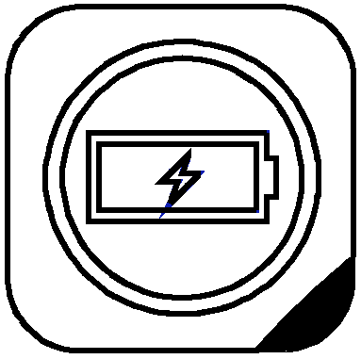Spotlight.

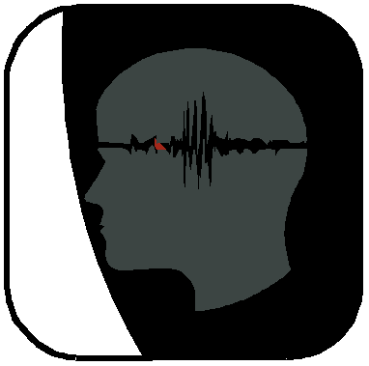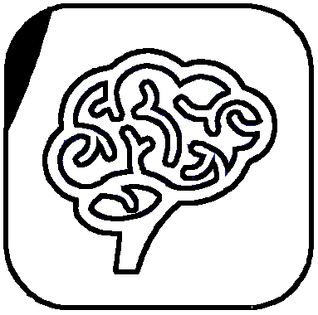

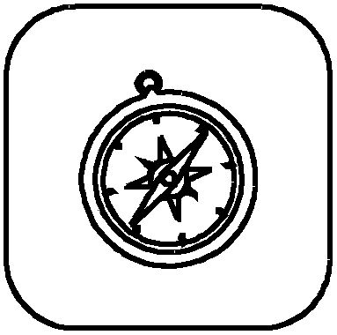

FLEX to connect
COPE to thrive

© Mindflick Ltd 2018. All rights reserved.
A ® ebook
Spotlight.
BEHAVIOURAL STYLE
& MINDSET.

Spotlight is a personality profiling tool, designed with performance in mind.

Based on the science of psychology, along with decades worth of experience in elite sport, we built Spotlight to be practical, memorable and relevant to the modern world.

Our experiences in the world of elite sport taught us a hard lesson about character… people change when there’s something to be won and lost.

In fact, it taught us that it wasn’t enough to just understand ‘Behavioural Style’, we also had to consider ‘Mindset’. Put simply, some people were trying to win, whilst others were trying not to lose - with both proving to be successful strategies when applied skilfully.

As a result, we explored the major dimensions of character based on the properties of the brain-behavioural systems. This included the basic processes of motivation, learning and emotion.

Taking these lessons, we developed a way of understanding both ‘Behavioural Style’ and
‘Mindset’, combining them into what we call
‘’Performance Preferences”.

Spotlight has been applied with organisations and teams from a wide range of fields, from elite sport to the financial sector. Our aim was to design a tool that could be applied in any context, to help people move forwards.
Since developing Spotlight, we’ve undertaken research studies, establishing both the profile’s validity and reliability. We’ve also tested it across a wide range of sectors and client groups.

We’ve learnt a lot from our clients and how they relate to Spotlight, shaping the profile and tailoring the content to ensure its impact is both immediate and long-lasting.

We hope you enjoy this short ebook and that it helps to explain how Spotlight can be applied within your context.

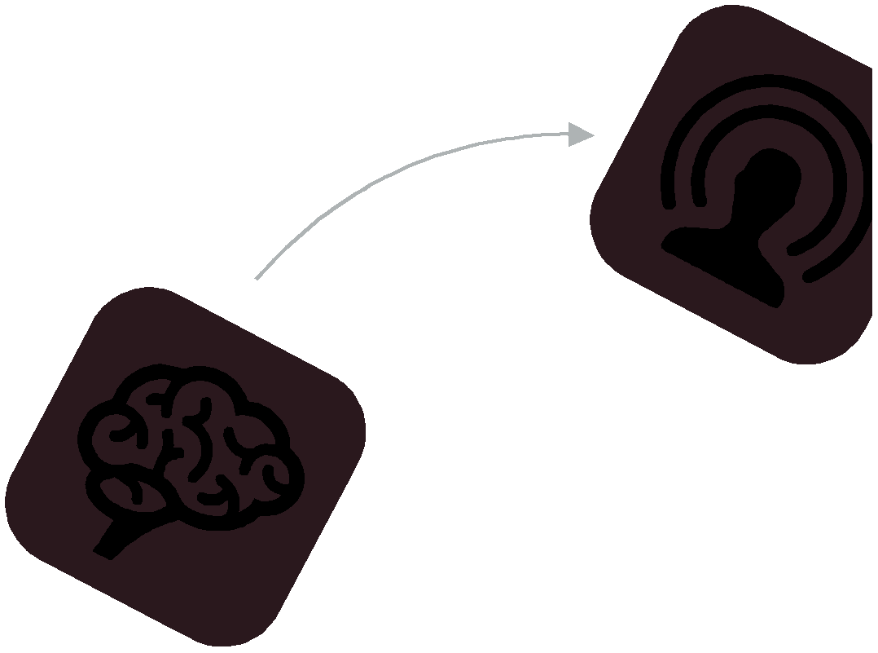We’d love to help you bring Spotlight to your organisation, so please get in touch.

It’s about moving.
PROFILING WITH
A MODERN TWIST.

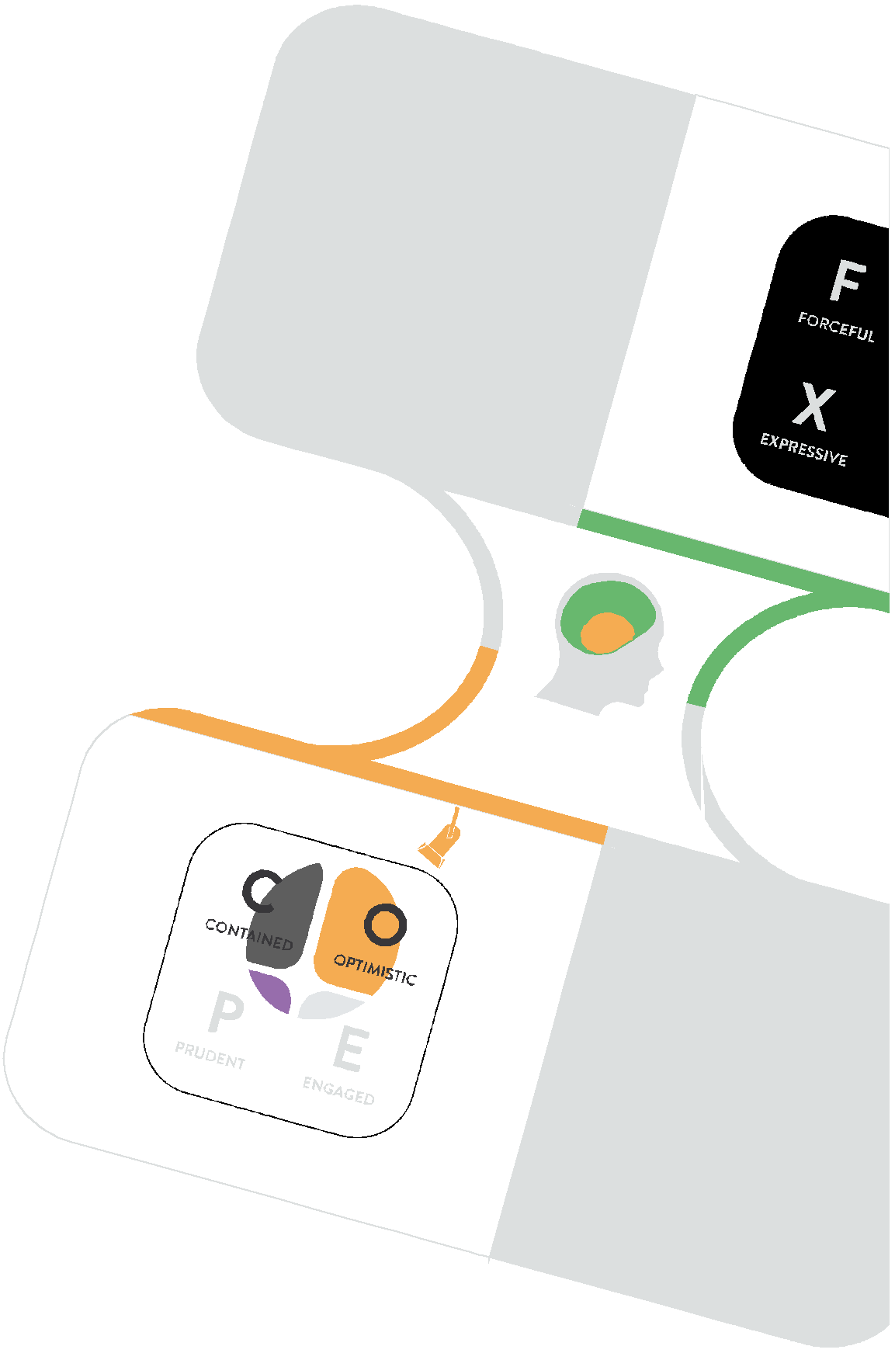Despite a long history of psychological ‘typing' and its application, recent research and the rapidly changing nature of the workplace means that simply understanding psychological preferences is no longer enough.

With this in mind, Spotlight approaches things slightly differently.

The core principles of Spotlight are:

๏ People change when there’s something to be won or lost (and there’s increasingly something to be won or lost in our daily interactions)
๏ Modern personality theory shows that we change across contexts, and with volitional effort - it’s important to recognise and understand this shift
๏ To connect and thrive in the modern workplace, it’s important to be able to FLEX our behavioural style and COPE in a variety of ways, depending upon the mindset that we need
๏ It’s therefore less about “where you are” (on the
profile) and much more about “where you can get to”
๏ Our weaknesses are often our strengths over- played - anything to excess becomes toxic

S o w i t h S p o t l i g h t , w h i l s t we b e g i n w i t h understanding your natural preferences, we quickly move onto how you might FLEX to connect with others, and COPE in order to thrive.

How it works.

MIRROR, SIGNAL, MANOEUVRE.

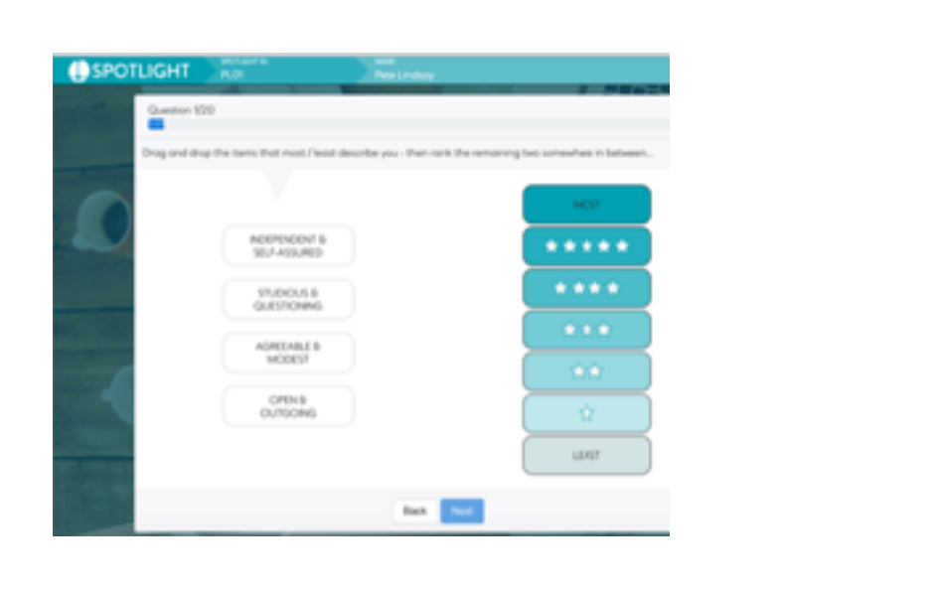Spotlight can be used by anyone who is interested in getting the best out of themselves and others.
01

Using a combination of workshops, coaching, and personal development, Spotlight can be used by organisations to embed a new way of thinking about performance and people.

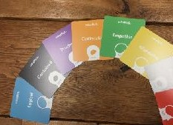Clients begin by completing the simple and intuitive online questionnaire - a quick, 15 minute process.
02

The in-depth Spotlight reports are then generated along with corresponding team maps.

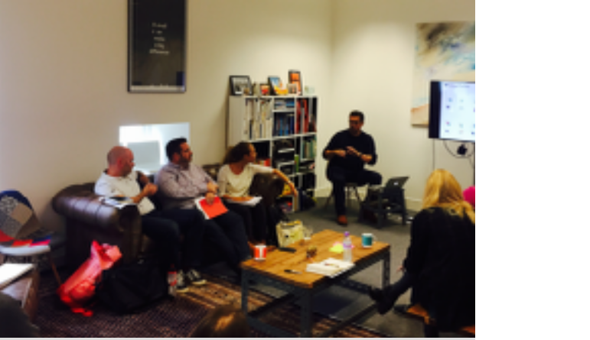It’s often best to bring together a whole team, or group of individuals to experience a Spotlight workshop - ranging anywhere f rom 2-hours to 2-days. During the workshop individuals explore the models, understand their own and their team’s preferences, and coach one another in how to FLEX and COPE.
03

Following a workshop, we recommend that each Spotlight profile is also individually debriefed. This really brings the learning to life for the individual, helping them connect with other more effectively, and thrive in their roles.

